Preparing a two column extended abstract paper with MS Word for Windows
A. Unknown & C. Unknown
A.A. Balkema Publishers, Leiden, The Netherlands
B. Unknown
New Institute, Gouda, Netherlands

Abstract

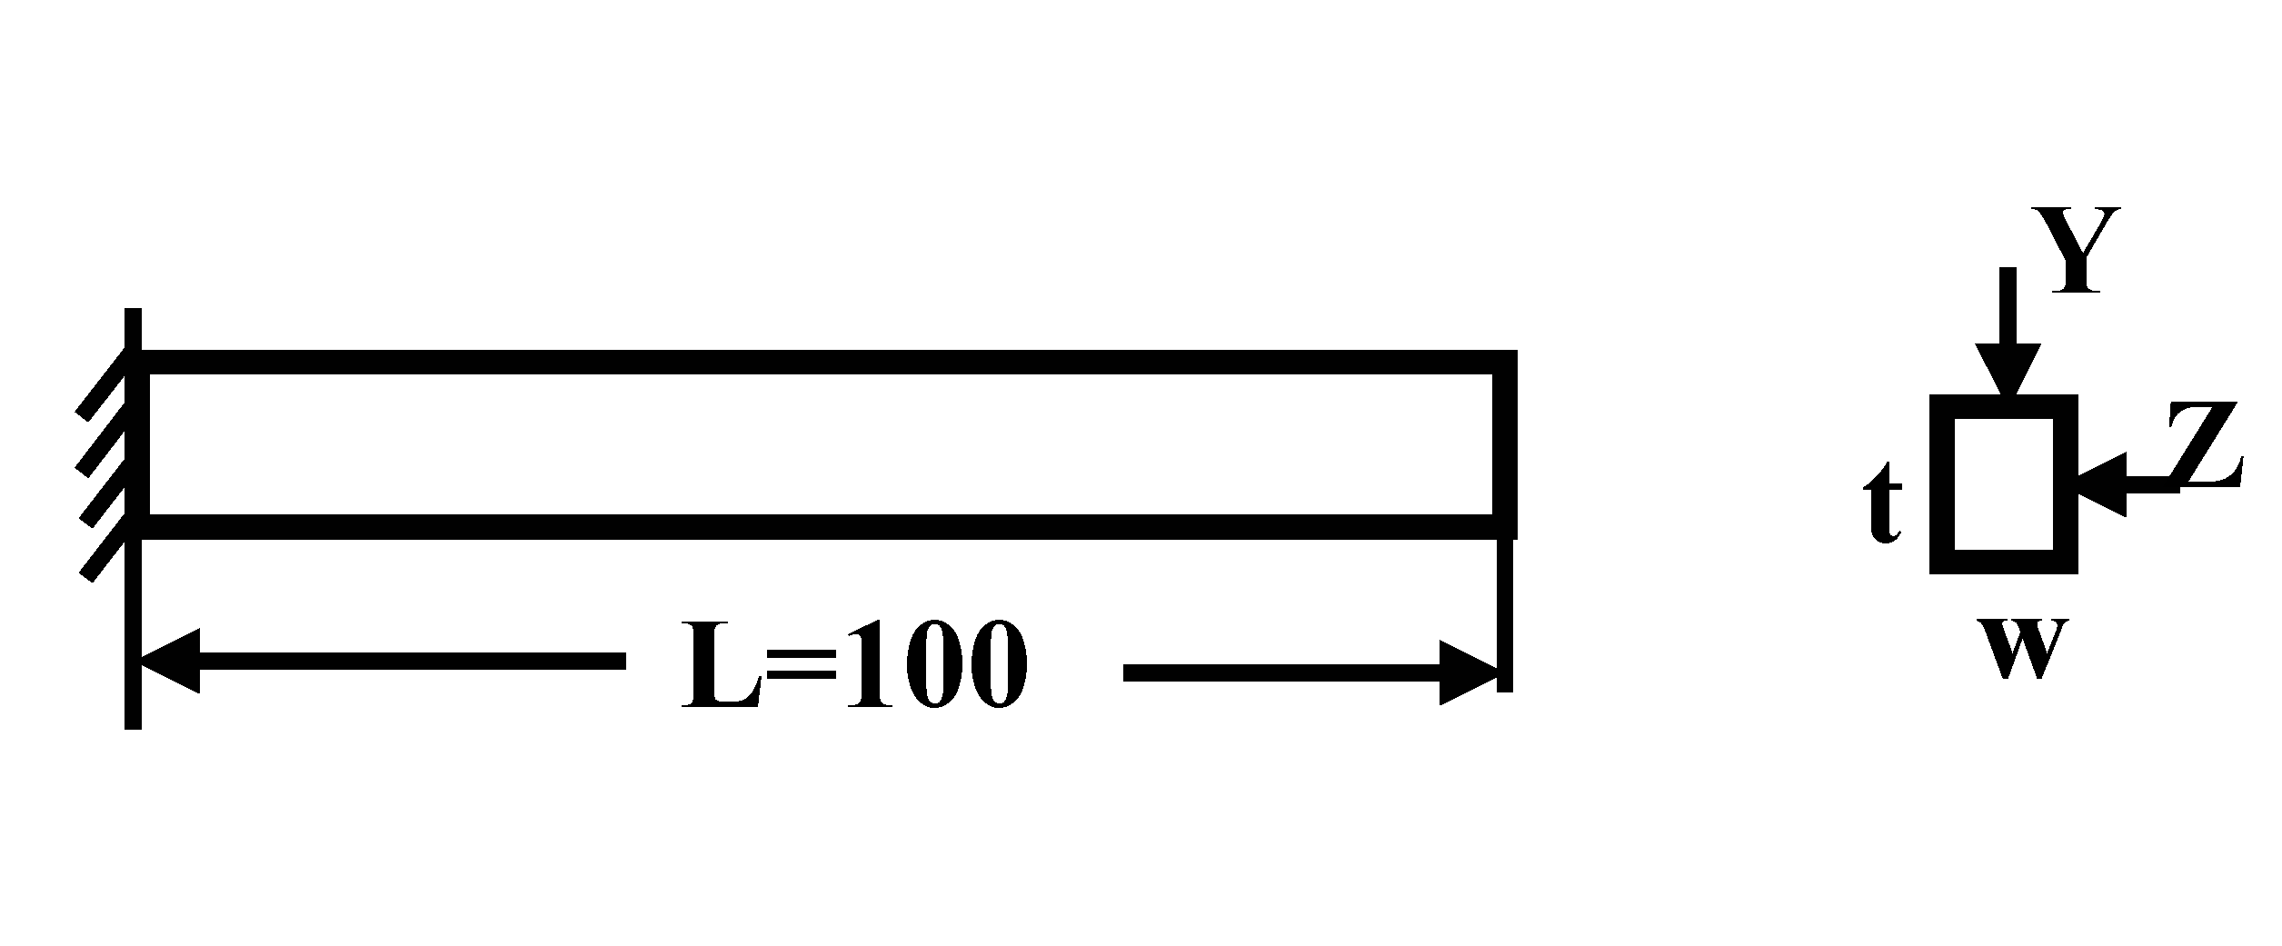
The text in this paper is for visual purpose only. No rights can be taken from this.
A detailed riparian field study to assess the importance of bedrock groundwater in streamflow processes was established in the headwaters of the Afon Hafren, mid-Wales, UK. Results from this study identified distinct groundwater horizons close to the stream channel. Different flow pathways and travel times resulted in a different chemical character of groundwaters in these different horizons. Groundwater discharge from these horizons into the stream was by piston displacement in response to recharging rainfall higher up in the catchment. Groundwater upwelling into the soils indicated soil water to be sourced from both groundwater and rainfall. Soil waters closest to the stream (ca. 25m) were predominantly groundwater controlled and may be the major source for ecologically toxic soil components such as aluminium entering the river. The role of groundwater in upland streamflow generation is far more complicated than previously considered and has important implications for upland water quality.
A detailed riparian field study to assess the importance of bedrock groundwater in streamflow processes was established in the headwaters of the Afon Hafren, mid-Wales, UK. Results from this study identified distinct groundwater horizons close to the stream channel. Different flow pathways and travel times resulted in a different chemical character of groundwaters in these different horizons. Groundwater discharge from these horizons into the stream was by piston displacement in response to recharging rainfall higher up in the catchment. Groundwater upwelling into the soils indicated soil water to be sourced from both groundwater and rainfall. Soil waters closest to the stream (ca. 25m) were predominantly groundwater controlled and may be the major source for ecologically toxic soil components such as aluminium entering the river. The role of groundwater in upland streamflow generation is far more complicated than previously considered and has important implications for upland water quality.

Figure 1. Sample of a figure caption

A detailed riparian field study to assess the importance of bedrock groundwater in streamflow processes was established in the headwaters of the Afon Hafren, mid-Wales, UK. Results from this study identified distinct groundwater horizons close to the stream channel.

Table 1. This a table caption
Items | Properties
Concrete | C50
Steel fiber | Hooked steel wire fiber, L=50 mm, L/d=55, Blend capacity=60 kg/m3
Polypropylene fiber(PP fiber) | Dispersed monofilament fiber, L=12 mm, d=18 μm, Melting point=160 °C, Blend capacity=2 kg/m3
References
Donald, A.P. and Gee, A.S., 1992. Acid waters in upland Wales: causes, effects and remedies. Environmental Pollution, 78, 141-148.
Duff, P.M.D. and Smith, A.J., 1992. Geology of England and Wales. The Geological Society, London.
Haria, A.H. and Shand, P., 2004. Evidence for deep sub-surface flow routing in forested upland Wales: implications for contaminant transport and stream flow generation. Hydrology and Earth System Sciences, 8(3): 334-344.

